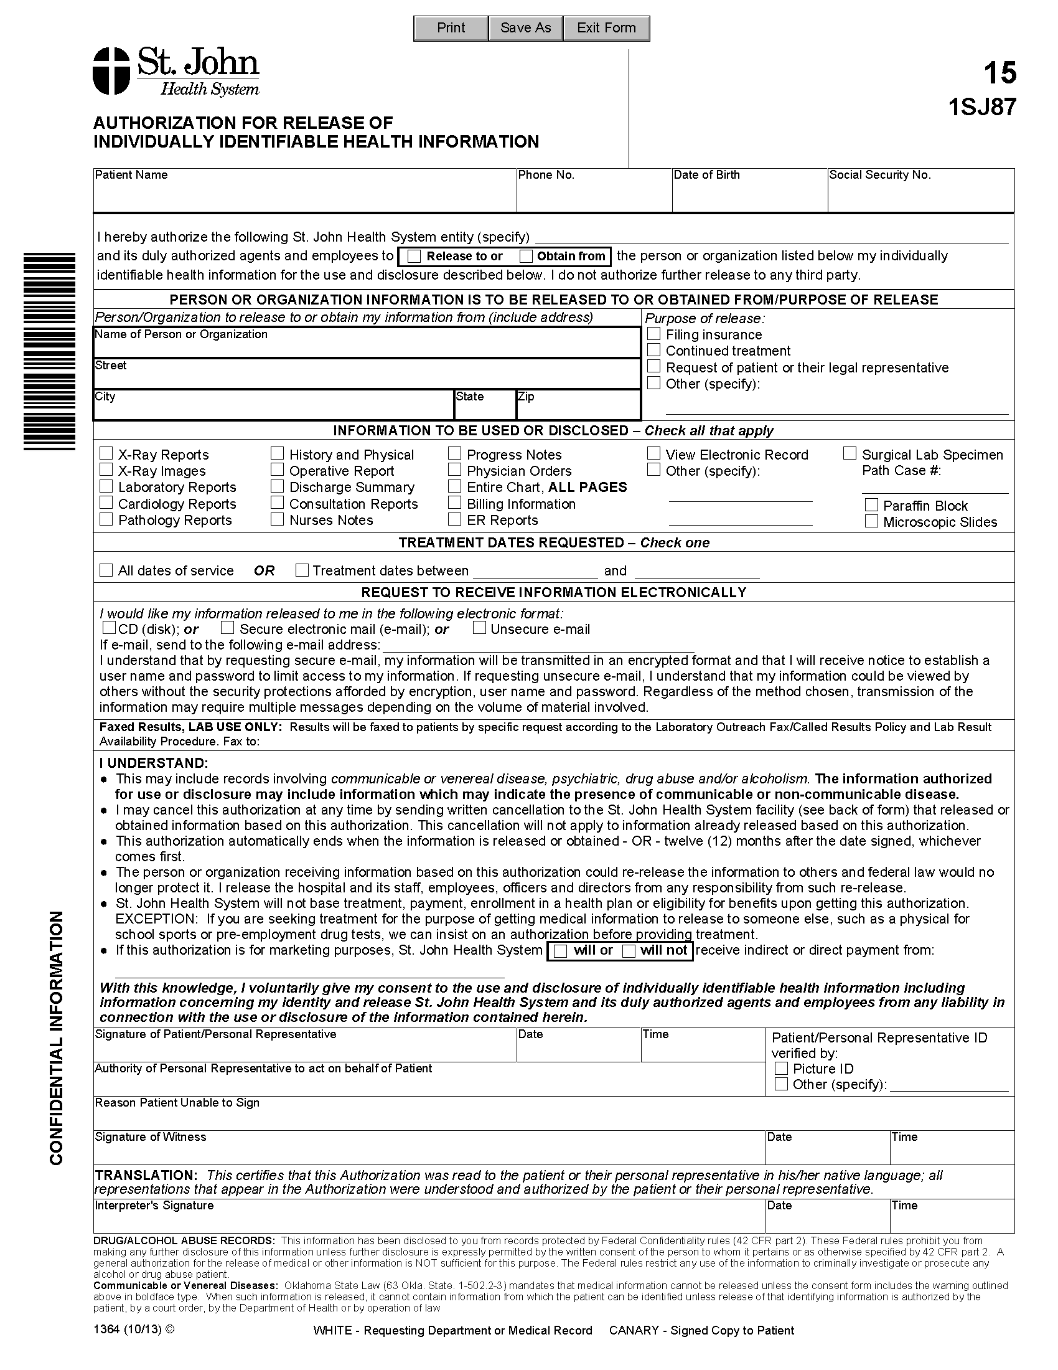

Batman

01/01/1979
xxx-xx-5555
Axiom Requisition Copy Service
2869 Jolly Road
Okemos
MI
48864
Litigation
X
X
University of Michigan Hospital and Health Center
FROM 01/01/1979 TO PRESENT: Any and all MEDICAL RECORDS, including but not limited to patient history form(s), reports, etc. pertaining to Batman SSN: xxx-xx-5555, DOB: 01/01/1979.
X
Records@axiomcopy.com
Order No 01-29018-002
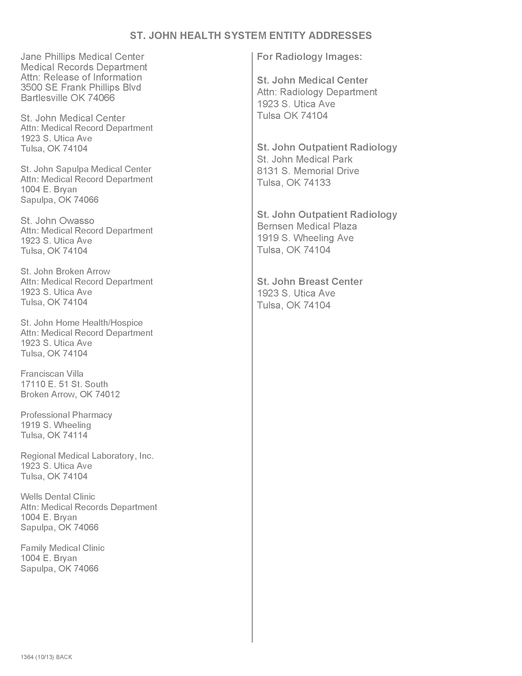
Order No 01-29018-002

